Terraform Task
Task Description:
Launch Linux EC2 instances in two regions using a single Terraform file.

Install Terraform file.
sudo yum install -y unzip wget
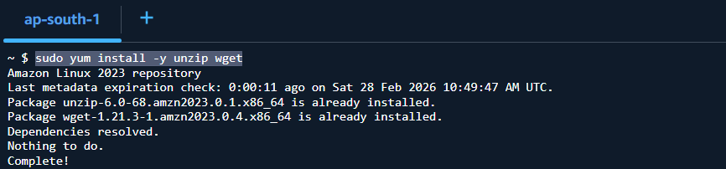

wget https://releases.hashicorp.com/terraform/1.8.5/terraform_1.8.5_linux_amd64.zip
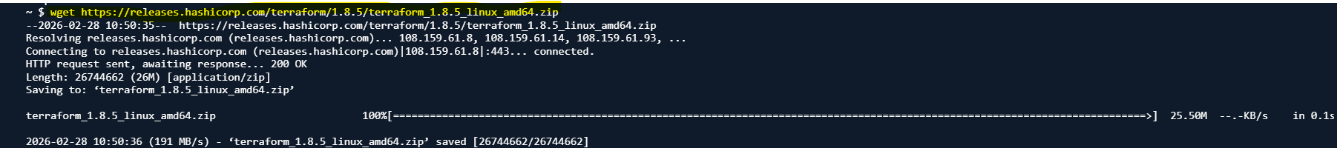

unzip terraform_1.8.5_linux_amd64.zip
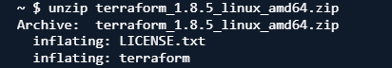
sudo mv terraform /usr/local/bin/
terraform version
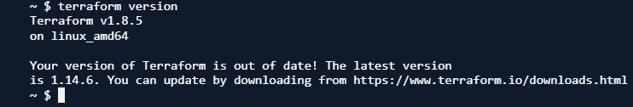

Main.tf

provider "aws" {
region = "eu-central-1"
}
provider "aws" {
alias = "us"
region = "eu-west-3"
}
resource "aws_instance" "europe-frankfort" {
ami = "ami-0df0e4e99bf8601b4"
instance_type = "t2.micro"
tags = {
Name = "europe-frankfort"
}
}
resource "aws_instance" "europe-paris" {
provider = aws.us
ami = "ami-0c5c1b3399d21cdc6"
instance_type = "t2.micro"
tags = {
Name = "europe-paris"
}
}

terraform init
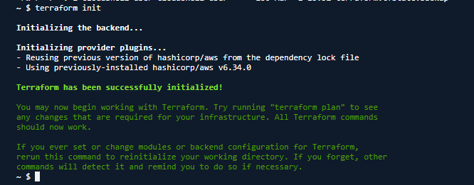
terraform validate

terraform plan
terraform apply
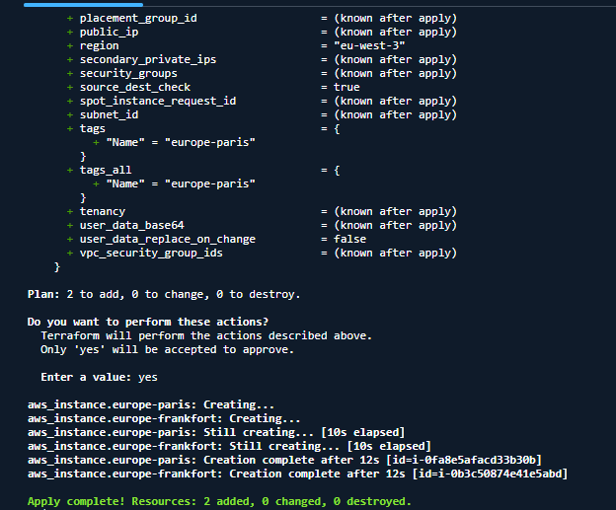
eu-central-1
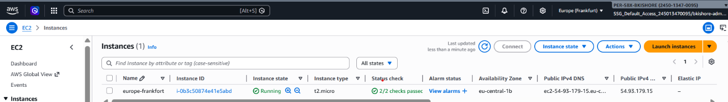
eu-west-3
